Cumberland Coal Cross
From the Village Park
September 26, 2010

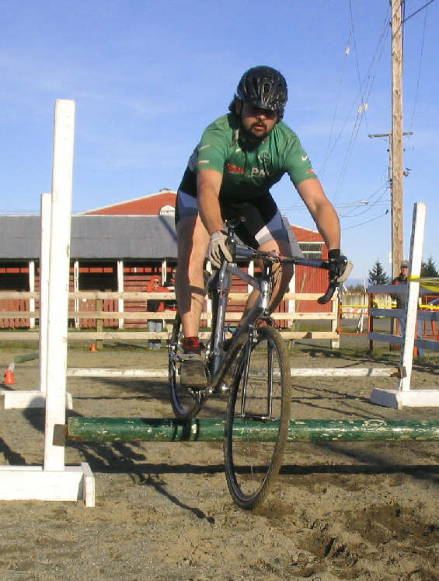

Race #1 in the Cross on The Rock Series

“Coal Cross” is brought to you by: 




















^{CROSS ON THE ROCK}
^{WWW.CROSSONTHEROCK.COM}
Vancouver Island Cyclocross

Technical and Race Guide
Race #1: Village Park, Cumberland
September 26, 2010

Index
- Cumberland Coal Cross Course and Venue Description
- Event Schedule
- Awards Schedule
- Directions
- Event Categories
- Registration Information
- Event Rules
- Series Rules
- Results

1. Course and Venue Description
Register at:
Cumberland Village Park, Cumberland.
Located at 6th street and Dunsmuir (Main Street), Cumberland BC
Course Description:
Course Designer: Curtis Saunders
This course winds its way through the Village Park of Cumberland. It starts At the quad track (on 6th street and Kerwick ave) adjacent to the Village Park and takes you through the Village Park and the surrounding features, such as the bmx track and the quad track adjacent to pump track. There is a good mix of grass, gravel, mud, cobbles, and minimal asphalt. The course looks wide open but the grass, run up and treed corners makes this course more technical than you would think it would be. The start will give a straight away of asphalt and gravel with a hairpin turn 100m down the road to enter the Park. Expect to see the return of the “whirly whirl” and then to shoot into the snakes and ladders forest. Riders will then be careened into the Coal Hills BMX track and expected to navigate a newly cleared route above it to get to the Sandpit of Despair. The course will then weave its way through the gopher holed, cobbled road beside the park and riders will want to vie for the holeshot to enter a small route adjacent to the pump track near the start line. The finish line will run out along 6th (Past the start line) and end at the water park facilities just before the corner of 6th and Dunsmuir.

Accommodations:

The Riding Fool Hostel is situated in the Heart of Dodge City (Cumberland) and is located alongside the course and walking distance from the No. 6 mine park. They have a great common area complete with couches and a cozy fireplace. For reservations call 1-888-313-FOOL or visit them on the web at www.ridingfool.com

Comments from the race director…
At all times it is important to recognize that we are guests in the Village of Cumberland and to limit your impact and minimize your disturbance. We have been given generous access to the Village park’s terrain and facilities for this event. All competitors should treat this venue with extreme care. If we can continue to show that we have a responsible group who respects the Village, we can expect to be invited back in years to come. Consider yourselves ambassadors for the sport of Cross and the series.

2. EVENT SCHEDULE (PLEASE NOTE TIME CHANGES FROM PREVIOUS EVENTS)
Registration: 11:00-2:50 (up to 20min before your race)
Pre-Riding: Course open for pre-riding from 11:00
(NO PRE-RIDING WHEN RACES ARE IN PROGRESS)

BEGINNER ONLY Clinic and Pre-Ride with Wendy Simms will be at 11:15. You need to be registered and you need to be a beginner to go in this mini-clinic. Wendy will show you the course, go over basic skills and answer any questions….but again….for BEGINNERS.

Beginner Race: 12:00-12:45(race approx 30min for 1st person). Divided into men and women if enough people
Pre-ride:12:45-1:00
Intermediate Race: 1:00-1:45 (approx 40min for 1st person)
Pre-ride: 1:45-2:00
Master’s and Women’s Race: 2:00/2:01-2:50 (approx 45min for 1st person):
Pre-ride 2:50-3:15
Expert: 3:15-4:15 (60 min for 1st person)
Awards soon after.

3. AWARDS SCHEDULE
Awards for beginner and intermediate follow the intermediate race.
Awards for Masters, Women’s and Elite to follow the Elite race.

4. Directions to Cumberland
For maps and more detail, please use this Google Maps link: http://maps.google.ca/maps?f=q&source=s_q&hl=en&geocode=&q=6th+and+dunsmuir,+cumberland,+bc&sll=49.815377,125.081918&sspn=0.692947,2.045517&ie=UTF8&hq=&hnear=Dunsmuir+Ave+%26+6+St,+Cumberland,+Comox-Strathcona+Regional+District,+British+Columbia&z=17
Registration is located at the Water Park Facilities of the Village Park, at 6th and Dunsmuir.

From the Mainland via Departure Bay Ferry Terminal:

Get off your boat and follow the flow of traffic north to Hwy 19A/Island Hwy N. Travel north for approximately 60 minutes or 100km.

Take exit- EXIT 117 toward Cumberland/Courtenay/Comox

Turn LEFT onto Cumberland RD

Veer/Turn slight left onto 4th street (at the Cumberland Peace Park sign).

Turn Leftt onto Dunsmuir, Continue along Dunsmuir through town to 6th Ave. You will see the Village Park sign and the water Park immediately on your right.

Please park along Dunsmuir or at the Coal Hills BMX track, as the race organizers will need to keep 6th Ave open for the race course.

From Victoria/Down Island:

Start out going NORTH on DOUGLAS ST / PROVINCIAL ROUTE 1 / TRANS CANADA HWY. Continue to follow PROVINCIAL ROUTE 1 N / TRANS CANADA HWY N.

Stay on the Island HWY until you reach Nanaimo and hwy turns into Provincial Route 19N inland island hwy. Travel for approximately 100km or 60 minutes.
Take exit- EXIT 117 toward Cumberland/Courtenay/Comox

Turn LEFT onto Cumberland RD

Veer/Turn slight left onto 4th street (at the Cumberland Peace Park sign).

Turn Leftt onto Dunsmuir, Continue along Dunsmuir through town to 6th Ave. You will see the Village Park sign and the water Park immediately on your right.

Please park along Dunsmuir or at the Coal Hills BMX track, as the race organizers will need to keep 6th Ave open for the race course.

5. EVENT CATEGORIES

Beginners: All men and women beginner racers who are not quite ready for the other categories. These racers will have done none, one or two cross races and feel they are not ready to move up. We will have a separate start and results for men and women if there are more than 5 people per gender.

NOTE: There is a feeling that after 3 races you MUST move out of beginner….that is not the case….IF you feel like you should still be racing beginner than please do so. If you are killing all the beginners each race…well then we will probably ask you to move up. Most importantly we want you to come out and have fun with as little pressure as possible.

Women: All women unless they are beginners. We will have a separate start for women just after the Masters Category.

Masters: All Masters level racers that are 35+ years old. Masters level racers may also choose to race in the Expert category if they feel they want the extra heat.. We would really like to encourage all racers over 35 years old to race the masters category instead of Intermediate to balance out the fields and give the masters category more depth.

Intermediate: Category 4 and 5 licensed road riders
(or MTB Novice or Sport)

Expert: Category 1, 2 and 3 licensed road riders (or MTB Elite Expert or Sport)

If we feel you are sandbagging then we will “politely” ask you to move up a category or two.

6. REGISTRATION INFORMATION

Sorry a Cycling BC, Masters Cycling BC or other cycling association license does not cover you for this or any of our series events for this year.

There will be no pre-registration for this race.

All registration will be done on-site up to 20 minutes before each event.

Entry fee is $20 for Masters, Women, Expert and Intermediate.

For Beginners the race entry fee is $10 with or without a license. No license needed to race in Beginner category.
- Learn to race cyclocross clinic is Free for all registered racers in any category. 11:15 start time for Coal Cross
- NOTE: You must be registered before you do the clinic.

7. EVENT AND SERIES RULES
- Good sportsmanship and fair play are our number one rule!
- These races are designed to be fun “club” level events. This is not to say that they will not be challenging or competitive BUT we are not as serious as some other events out there.
- Riders must posses a current Cycling BC license or pay for a one day Cycling BC license ($10 at our events). Beginners exempt.
- All events are open to any type of bike; road, mountain or cross. A cross bike should be your first choice followed by a mountain bike….road bikes will not enjoy our courses…
- UCI cyclocross bike rules do not apply in our events. Run any tire width you like, flat bars are fine….if you have any questions please let us know.
- Call up at the first series event at Cumberland is RANDOM to give everyone an equal chance of getting the front line and also making it so you don’t have to go to the line so early. From event #2 onwards call up for up to the top 25 will be based on series points for those ranked and then random for all remaining racers.
- All riders will finish on lap following the leader finishing the race.
- Other than these specific rules regular cross rules and common sense will dictate everything else.
- The race organizer and or official have the final say in everything!
- At Cross on the Rock events racers are not pulled if they are lapped by the leaders of their event. All racers finish on the lead racer’s lap so you are never more than one lap down nor do you race much longer than the leader of your race. IF you do not finish on the lead racer’s lap then you will receive a DNF.

9. SERIES RULES
- Points will be given out in to all participants in each category with the exception of beginners. If you move up from intermediate or masters to expert during the year you will retain 50% of your points.
- Because we have 7 events this year for the first time we will again have a throw away for your worst result/missed event.
- We have expanded the points structure based on feedback that even the guys in the back want to beat their buddies I the series.
- 2010 Points are distributed as following:

Placing | 1 | 2 | 3 | 4 | 5 | 6 | 7 | 8 | 9 | 10 | 11 | 12 | 13 | 14 | 15
Points | 30 | 27 | 25 | 24 | 23 | 22 | 21 | 20 | 19 | 18 | 17 | 16 | 15 | 14 | 13

Placing | 16 | 17 | 18 | 19 | 20 | 21 | 22 | 23 | 24 | 25
Points | 12 | 10 | 9 | 8 | 7 | 6 | 5 | 4 | 3 | 2

2 Points will be given out to any finisher 25th and beyond.
The rider must finish the entire race and can not be a D.N.F.

The last race is double points and thus will be double the above point break down.

Series Awards are given for the top 3 in the following categories: Expert, Intermediate, Women and Masters.

AS a BONUS this year we will also be giving out a series prize to:
- the top Novice/Cat4/5 women that races in the Open Women Category
- the top 50+ Masters racer in the Masters Category

Series prizes will be presented at the last event at Shawnigan Lake School….you must be there to claim them as we do not do mail outs.

Special Thanks to:
- To The Village of Cumberland for allowing us to use this venue.
- Our host Cycling Club; Trail Bikes/ Eatmore Sprouts Cycling Team.
- Our Local Bike Shop Sponsor; Trail Bicycles and Jeff Beeston
- All our volunteers, marshals and post pounders
- Our first time race director: Lisa Ludwig

Any Questions?
Feel free to contact me at this e-mail address.
Normon Thibault at normont@islandnet.com
www.crossontherock.com

Cross on the Rock is brought to you by our awesome sponsors:

Series is Organized by the Cross Council:
With the following cycling clubs: VICC, Experience Cycling Club, UROC, Arrowsmith MTB Club and IRC

Supported by:
OBB Victoria, Westshore and Nanaimo
Trail Bikes in Courtenay
Experience cycles in Duncan
Frontrunners in Nanaimo
Straight Up Cycles in Victoria
Dodge City Cycles in Cumberland

Sanctioned by:
Cycling BC

